Comparative Analysis of BRCA1 Orthologous DNA and Protein Sequences to Identify Conserved Functional Regions Across Species
Submitted By: Deksita Sasikumar
Date: 20th June 2026

INTRODUCTION
A gene is a unit of DNA that carries instructions to make proteins. One important gene is BRCA1, which acts as a tumour suppressor and plays a key role in repairing double-strand breaks in DNA. When BRCA1 does not function properly, DNA damage can accumulate, increasing the risk of cancers, especially breast and ovarian cancer.
With the help of databases like NCBI, it is now possible to retrieve gene and protein sequences easily. These sequences can be analysed using tools such as BLAST and Clustal Omega. Sequence alignment helps compare DNA or protein sequences to find similarities and differences and to understand how they have evolved.
Conserved regions are especially important because they tend to remain unchanged across species. This usually means they are essential for the function of the protein and are preserved through evolution.

OBJECTIVE
To perform a comparative analysis of BRCA1 gene sequences across selected vertebrate species, using both DNA and protein alignments, to identify conserved regions, functional domains, and to infer evolutionary relationships.

PRINCIPLE
Biological sequence analysis is based on a few key concepts:
FASTA format is a standard way of writing sequences, where each sequence has a header followed by the actual sequence.
BLAST (Basic Local Alignment Search Tool) is used to find similar sequences by comparing a query sequence with sequences in a database.
Multiple Sequence Alignment (MSA) allows comparison of more than one sequence at the same time to identify conserved regions and variations.
Conserved regions usually indicate important functional parts of a protein, while gaps in alignment show insertions or deletions that occurred during evolution.
Orthologs are genes in different species that have similar functions, making them useful for comparison.
Due to codon degeneracy, multiple codons can code for the same amino acid. Because of this, some changes in DNA do not affect the protein, which is why protein sequences are often more conserved than DNA sequences.

TOOLS USED
- NCBI
- Clustal Omega
- BLAST
- UniProt

METHODOLOGY
- The BRCA1 gene was selected due to its essential role in DNA repair.
- The BRCA1 gene sequences were retrieved from the NCBI database. The nucleotide sequence was obtained from the Nucleotide database, and its corresponding translated protein sequence was also identified. Additionally, the protein sequence was retrieved independently from the NCBI Protein database to ensure accuracy and enable detailed analysis.
The organisms selected are:
- Homo sapiens (Human)
DNA RefSeqID: NM_007294.4
Protein RefSeqID: NP_009225.1

- Pan troglodytes (Chimpanzee)
DNA RefSeqID: NM_001045493.1
Protein RefSeqID: NP_001038958.1

- Bos taurus (Cow)
DNA RefSeqID: NM_01192609.1
Protein RefSeqID: NP_001178097.1

- Rattus norvegicus (Rat)
DNA RefSeqID: NM_001106886.1
Protein RefSeqID: NP_001012031.1

- Mus musculus (Mouse)
DNA RefSeqID: NM_009764.3
Protein RefSeqID: NP_033894.3

- Gallus gallus (Chicken)
DNA RefSeqID: NM_204317.1
Protein RefSeqID: NP_990483.1

- Xenopus laevis (Frog)
DNA RefSeqID: NM_001090779.1
Protein RefSeqID: NP_001084248.1

- Multiple sequence alignment using Clustal Omega was performed separately for:
  - DNA sequences
  - Protein sequences
- Conserved regions, sequence variations, and alignment gaps were examined.
- Additionally, BLAST analysis was performed using the human BRCA1 sequence to identify the most similar sequence available in the database.
- Conserved functional domains were identified using annotated protein records.
- A phylogenetic tree was constructed to visualize evolutionary relationships.
- A percent identity comparison was used to interpret similarity across species.

RESULTS
- Sequence Retrieval

- Nucleotide sequence (DNA):
>Homo sapiens lcl|NM_007294.4_cds_NP_009225.1_1 [gene=BRCA1] [db_xref=CCDS:CCDS11453.1] [protein=breast cancer type 1 susceptibility protein isoform 1] [protein_id=NP_009225.1] [location=114..5705] [gbkey=CDS]
ATGGATTTATCTGCTCTTCGCGTTGAAGAAGTACAAAATGTCATTAATGCTATGCAGAAAATCTTAGAGT
GTCCCATCTGTCTGGAGTTGATCAAGGAACCTGTCTCCACAAAGTGTGACCACATATTTTGCAAATTTTG

- Protein sequence:
>Homo sapiens NP_009225.1 breast cancer type 1 susceptibility protein isoform 1 [Homo sapiens]
MDLSALRVEEVQNVINAMQKILECPICLELIKEPVSTKCDHIFCKFCMLKLLNQKKGPSQCPLCKNDITK
RSLQESTRFSQLVEELLKIICAFQLDTGLEYANSYNFAKKENNSPEHLKDEVSIIQSMGYRNRAKRLLQS

- Multiple Sequence Alignment

- DNA alignment
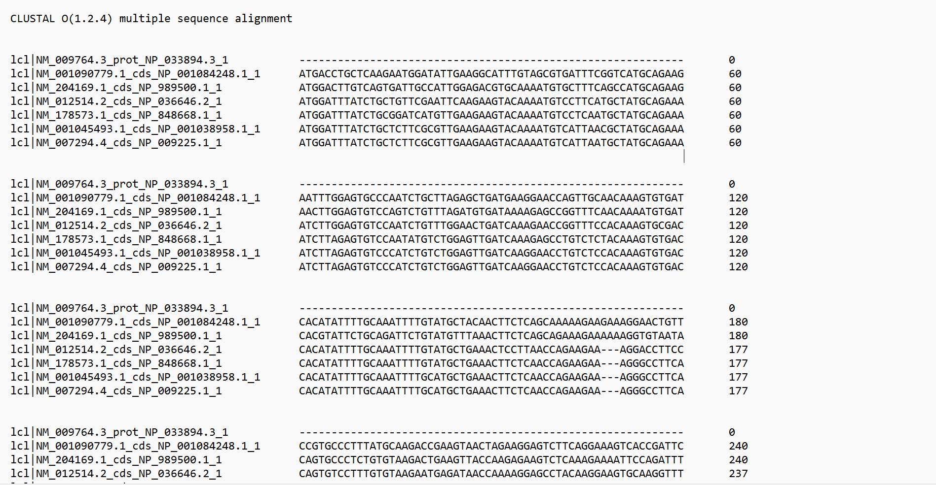
(Fig 1: BRCA1 human nucleotide sequence from NCBI)

Observation:
The DNA alignment showed moderate conservation across species, with several substitutions and gaps. This suggests that changes at the nucleotide level are more common during evolution.

- Protein alignment
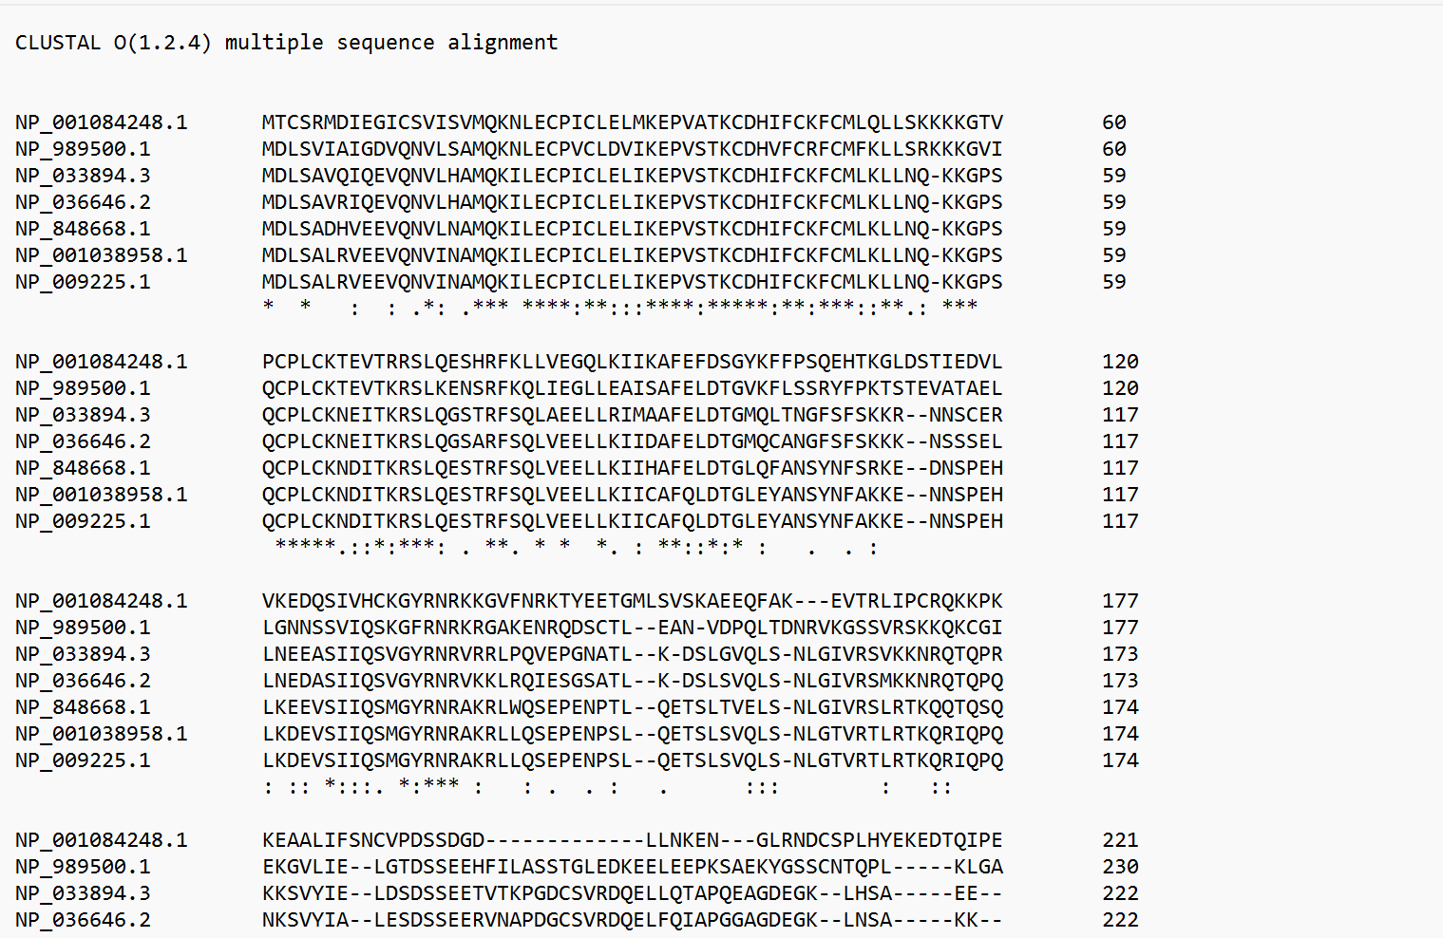
(Fig 2: BRCA1 human protein sequence from NCBI)

Observation:
It The protein alignment showed much higher conservation, especially in important regions. This indicates that these parts of the protein are essential and cannot change much without affecting function.
- BLAST Analysis

(Fig 3:BLAST result showing sequence similarity)

Observation:
The BLAST results showed that the chimpanzee sequence is the closest match to the human BRCA1 sequence, which is expected since they are closely related evolutionarily.

- Conserved functional domains

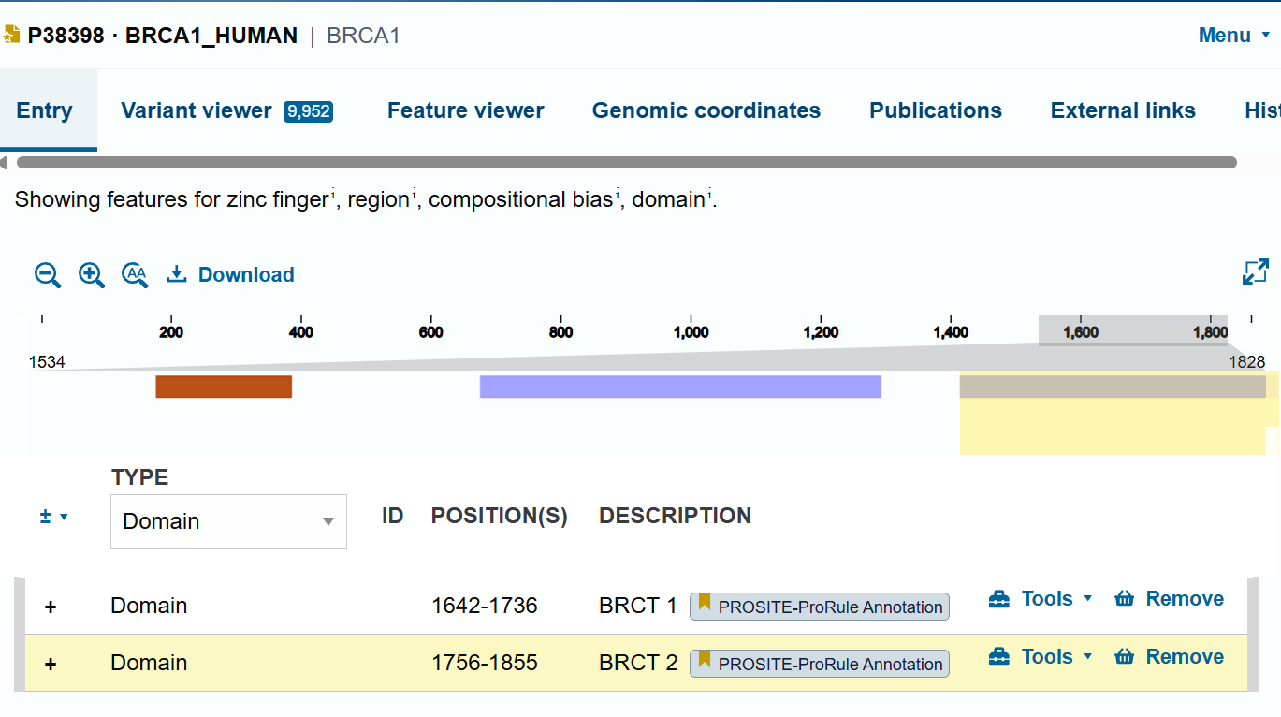
(Fig 4:UniProt Screenshot)

Observation:
The conserved regions in the alignment matched the RING and BRCT domains of the BRCA1 protein. This suggests that these domains are very important and have been preserved across species.

- Phylogenetic Analysis

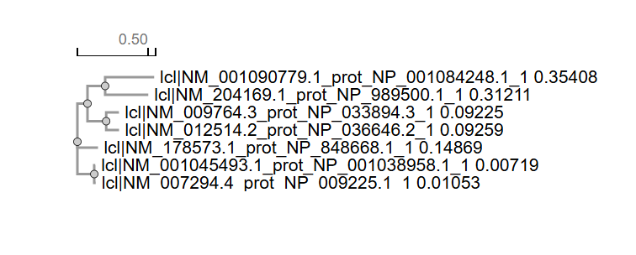
(Fig 5: Phylogenetic tree of BRCA1 protein sequence)

Observation:
The phylogenetic analysis showed clustering of closely related species, with primates grouped and distant species showing greater divergence.

DISCUSSION
Different species were selected to make the comparison more meaningful across a range of vertebrates. This helps in understanding how the gene has changed over time.
The comparison between DNA and protein alignments revealed that protein sequences are more conserved. This can be explained by codon degeneracy, where certain nucleotide substitutions do not alter the encoded amino acid, allowing DNA variation without affecting protein function.
The BLAST results highlighted a key observation: the human BRCA1 gene is most similar to that of chimpanzees. This is expected due to their recent common ancestry and explains why chimpanzees appeared as the dominant result.
Conserved regions identified in the alignment correspond to functionally important domains of the BRCA1 protein. These regions are likely under purifying selection, ensuring that critical residues remain unchanged over time.
The phylogenetic relationships observed further support the concept that sequence similarity reflects evolutionary distance.
Overall, the results show that the more important a region is for function, the more likely it is to stay conserved during evolution.

LIMITATIONS
- A limited number of species were analysed
- Alignment accuracy depends on sequence quality
- BLAST results were limited to highly similar sequences (chimpanzee), requiring manual selection of additional species
- No experimental validation of functional regions was performed

CONCLUSION
This study used sequence alignment and database tools to analyse the BRCA1 gene across different species. The results showed that protein sequences are more conserved than DNA sequences, and that important functional regions remain unchanged across species.
The findings highlight how bioinformatics tools can be used to understand gene function and evolutionary relationships in a simple but effective way.

